DATE: 27.12.2019
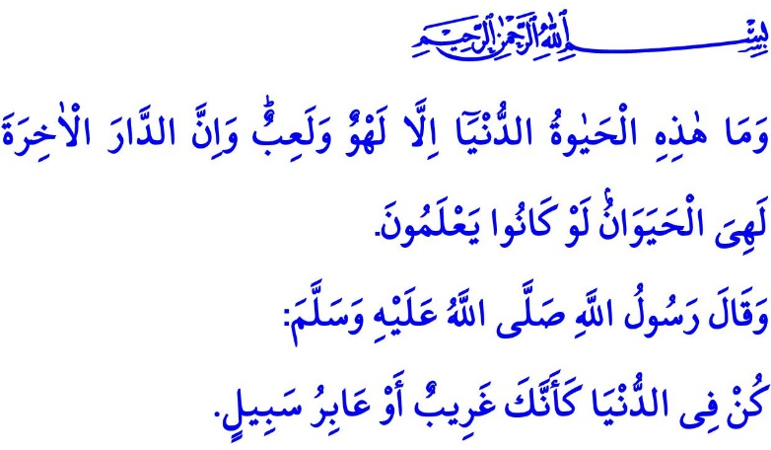
A LIFE FULL OF CONTEMPLATION
Honorable Muslims!
In the verse I have recited the Almighty Allah (swt) states, "And this worldly life is not but diversion and amusement. And indeed, the home of the Hereafter - that is the eternal life, if only they knew!"
In the hadith I have recited the Prophet Muhammad (saw) says, "Be in this world as if you were a stranger or a traveler."
Dear Believers!
We all have a limited number of days called life regardless of our current ages. One day that Allah knows only and not a moment earlier or a moment later than the predestined hour we all will leave this world after He takes our life entrusted to us. No other provision will we have than faith and a record of good deeds with us on our way to the place of resurrection where we will give an account for all we did in the world.
How lucky we are if we were able to know the value of time, the meaning of life, the importance of youth, and the gratitude for the blessings and health we have! Shame on us if we wasted our days, spent our wealth extravagantly, poisoned our mind or body, hurt our loved ones, and failed to properly perform our worships!
On these days with the beginning of a new year around the corner, by goes another year in our life, a step closer we are getting to our end. Then it is time for contemplation! Come, let us contemplate about what we have done in the previous year and about what spiritual abundances we have had and divine trials we have come through.
Dear Muslims!
At the beginning of the year about to be gone by we welcome the Three Holy Months. We celebrated Raghaib as the first blooming flower of mercy in the Three Holy Months, then Mi'raj as the clarity of our mind and the ease of our heart, and finally Night of Bara'ah as the peak of forgiveness. Did we truly regard these sacred days and nights as opportunities to refer our wishes to Allah (swt)? Did we truly hold fast on to performing the prayers that the Prophet Muhammad (saw) called as "the light of my eyes"? Did we show true regret for our faults and sins and repent for them?
Dear Believers!
As in every year, we were honored with Ramadan in this passing year. We reached the Laylat al-Qadr, more virtuous than a thousand months, and made it to the Eid al-Fitr. No matter how much gratitude we show, it is never enough! Because the holy month of Ramadan provided us with many opportunities to help and share with others while allowing us to enjoy the taste of spending in the way of Allah and treating well all creatures for the sake of Allah (swt). We attained abundance with suhur time, health with fasting, enlightenment with Qur'an, and peace with tarawih. Let us ask ourselves: Did we truly offer help and solution to the problems of our oppressed and needy brothers and sisters through the year after getting blessed with the abundance of Ramadan? Did we truly continue to live by Qur'an after the month of Qur'an came to an end? Did we truly, with our tongue uttering the name of Allah, heart feeling thankfulness, mind contemplating, body enduring, get accustomed to these fine virtues?
Honorable Muslims!
Also in this passing year, we celebrated the Eid al-Adha with our sacrifices for Allah that express our loyalty, thankfulness and submission. We observed the rights of our neighbors, relatives, the poor, and the orphan. We felt the Eid's atmosphere of peace, tranquility, and brotherhood. Did the past Eid al-Adha truly strengthen our devoutness, love and obedience for Allah (swt)? Did we truly maintain the spirit of giving charity and spending in the way of Allah through the year after the Eid? Did we truly get happy when we shared out?
Dear Believers!
Towards the end of this passing year, we celebrated the Mawlid al-Nabi Week for the memory of the Prophet Muhammad (saw) honoring the world. On the occasion of the Week, we paid more careful attention to his recommendations about family. We came to think again that compassion, fairness, trust and consultation were prevailing virtues in his family. Let us ask ourselves: Did we truly embrace our family values in his example? Did we truly protect our families we put our love to build through fairness and mercy? Did we truly solve our problems through common sense, never resorting to violence?
Dear Muslims!
The life in this world is a road to the Hereafter; the humans are travelers loaded with responsibilities; and the set number of days in this world is a challenging yet precious journey. Let us then not forget that we are merely travelers in this world. Let us live in a such a way as to value the worldly belongings as little as a traveler would need to, keeping in mind that our ultimate purpose is to enter heaven. Let us be aware of our life and the blessings in our possession. Let us spend every single day in such a way as would be approved by Allah (swt), doing useful deeds, with a good cause and without wasting the treasure of contemplation.

Ankabut, 29/64.
Bukhari, Riqaq, 3.
Nasai, Ishrat al-Nisa, 1. General Directorate of Religious Services

